2023
Year 12 Earth and Environmental Science – Unit 4
Task 9: Greenhouse Gases Investigation
Assessment Type: Science Inquiry
Weighting: 6%
Duration: 40 minutes

Name: _____________________

Date: ______________________

Total Mark | $${}/{20}$$

Please see SEQTA for teacher feedback and comments.

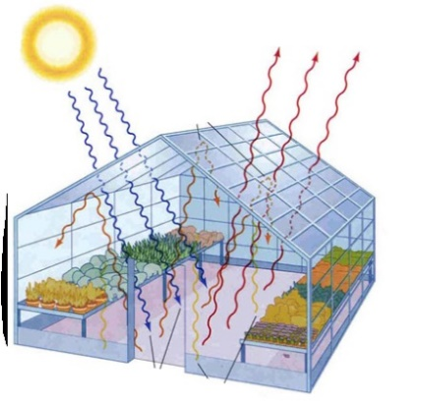
A student investigated the effect of the concentration of carbon dioxide on the temperature produced in a glass greenhouse. He used a garden greenhouse and measured the initial concentration of CO₂ and the temperature. Each morning, he increased the concentration of CO₂ (using bottled carbon dioxide) then recorded the temperature within the greenhouse at 4pm.

- Write a hypothesis for this student’s investigation. (2 marks)

________________________________________________________________________________________________________________________________________________________________________________________________________________________________

- Identify the dependent variable in this investigation. (1 mark)

_________________________________________________________________________

- Identify the independent variable in this investigation. (1 mark)

_________________________________________________________________________

- State two variables that the student controlled in his investigation. (2 marks)

________________________________________________________________________________________________________________________________________________________________________________________________________________________________

The following data was collected by the student.

Concentration of CO₂ (mg/L) | 10 | 15 | 20 | 30 | 40 | 50 | 65 | 80
Temperature inside the greenhouse (°C) | 25 | 31 | 36 | 43 | 48 | 49 | 54 | 55

- Draw an appropriate graph of this data with a line (curve) of best fit. (5 marks)

- Describe the relationship between the independent and dependent variables of this experiment. Be specific by referring to data from your graph. (2 marks)
____________________________________________________________________________________________________________________________________________________________________________________________________________________________________________________________________________________________________________________________________________________________________________________________________________________________________________________
- Does the description you wrote for question 6 support or not support the hypothesis you wrote in question 1? Circle your choice below and explain your reasoning. (1 mark)
Support / Does Not Support

- The student’s teacher told him that the investigation was not valid (a fair test).
  - What is a fair test? (1 mark)
_______________________________________________________________________________________________________________________________________________________________________________________________________________________________________________________________________________________________________________________________________

  - State one major error in the student’s investigation and explain why it makes the investigation invalid. (2 marks)
____________________________________________________________________________________________________________________________________________________________________________________________________________________________________________________________________________________________________________________________________________________________________________________________________________________________________________________

  - Suggest one way the student could alter the investigation to overcome the major error you outlined in 8b and how it overcomes the error. (2 marks)
____________________________________________________________________________________________________________________________________________________________________________________________________________________________________________________________________________________________________________________________________________________________________________________________________________________________________________________

END OF ASSESSMENT

